My Final Project

by
Israel Israeli

Approved by the supervisor: Dr. Eliav Menachi

Submitted to the Computer Science Faculty of College of Management
July 2023
Rishon LeZion
Acknowledgments
We would like to express our gratitude to …
We would also like to thank our families...
Executive Summary
[Provide a concise summary of your project, including its objectives, methodology, and key findings. Keep it within 250-300 words.]
Table of Contents
1. Introduction 8
1.1. Background 8
1.2. Problem Statement 8
1.3. Objectives 8
1.4. Scope and Limitations 8
1.5. Methodology 8
1.6. Organization of the Project Book 9
2. Literature Review 10
2.1. Overview of Relevant Literature: 10
3. System Design and Implementation 11
3.1. System Architecture 11
3.2. Data Collection and Preprocessing 11
3.3. Implementation Details 11
3.4. Evaluation Metrics: 12
4. Results and Analysis 13
4.1. Experimental Setup: 13
4.2. Presentation of Results: 13
4.3. Data Analysis and Interpretation: 13
4.4. Comparison with Existing Approaches 13
4.5. Discussion of Findings: 14
5. Conclusion and Future Work. 15
6. References 16
7. Appendix A: 17

Table of Abbreviations
AB - Access Bridges
AFSE - Approve First Service Establishing
AO - Administrative Owner
ARP - Address Resolution Protocol
Table of Figures
Figure 1: example how to add a figure 8

Introduction
This section provides background information, clearly define the problem, and explain the objectives and scope of your project. It sets the stage for the rest of your project book, providing a foundation for readers to understand the purpose and significance of your work.

Background
In this section, provide a background of the problem or topic your project aims to address. Discuss the context and significance of the problem, highlighting any relevant industry trends, technological advancements, or societal needs that motivated your research.

Problem Statement
Clearly define the problem that your project aims to solve or the research question it seeks to answer. Describe the specific challenges or issues associated with the problem and explain why it is important to address them.

Objectives
State the objectives of your project. These are the specific goals you aim to achieve through your research or implementation. Your objectives should be clear, measurable, and aligned with the problem statement.

Scope and Limitations
Define the scope of your project, outlining the boundaries and extent of your work. Discuss what aspects or components you will include and exclude from your project. Also, identify any limitations or constraints that may affect the scope or outcomes of your project

Methodology
Explain the research or development methodology you adopted to carry out your project. Describe the steps, procedures, or processes you followed to collect data, conduct experiments, implement your solution, or analyze results. Provide a high-level overview of the approach you took.

Organization of the Project Book
Briefly outline the structure and organization of your project book. Mention the main chapters and sections, along with a summary of the content covered in each. This helps the reader navigate through your project book and understand its flow.

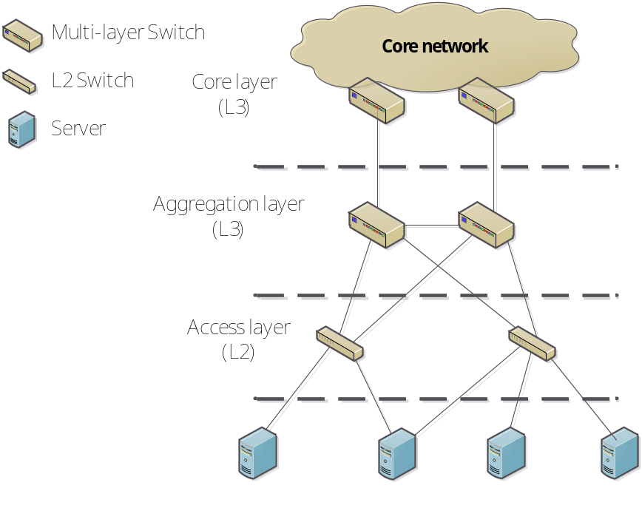
Figure 1: example how to add a figure

Literature Review

Overview of Relevant Literature:
In this section, provide an overview of the existing literature and research that is relevant to your project. Summarize the key concepts, theories, and approaches that have been explored by other researchers in the field. Discuss the main themes, trends, and debates in the literature related to your project topic. Make sure to include all the relevant material in the references section and to add the number of reference you relate to in your text like this [1].
By conducting a comprehensive literature review, you demonstrate your understanding of the existing knowledge in the field and position your project within the broader research landscape. This chapter provides a foundation for your project, helping you identify research gaps and establish the significance of your work.

System Design and Implementation

System Architecture
In this section, describe the overall architecture of the system or software that you have developed for your project. Explain the high-level components, modules, and their interactions within the system. Provide a diagram or visual representation to illustrate the system architecture. Discuss the design principles or patterns employed in the architecture and explain how they support the functionality and objectives of your project.

Data Collection and Preprocessing
If your project involves data collection, discuss the methods, tools, or techniques used to collect the necessary data. Explain how you ensured data quality, accuracy, and reliability. If your project involves preprocessing or cleaning of data, describe the steps or algorithms used for data preprocessing. Discuss any challenges or considerations you encountered during the data collection and preprocessing phase.

Implementation Details
Provide a detailed account of the implementation process of your system. Explain the programming languages, frameworks, libraries, or tools used for implementation. Discuss any specific algorithms, data structures, or techniques implemented in your system. Include code snippets or pseudocode to illustrate important aspects of your implementation. Explain any design decisions or trade-offs you made during the implementation phase.
List and describe the software and hardware specifications of the system you developed. Provide details about the programming languages, frameworks, databases, operating systems, or any other relevant software components used in your system. If your project involves hardware components or requirements, specify the hardware specifications, such as processors, memory, sensors, or any other relevant hardware details.

Evaluation Metrics:
Explain the evaluation metrics or criteria used to assess the performance, effectiveness, or efficiency of your system. Discuss how you measured and evaluated the success of your system against these metrics. Provide a detailed analysis of the evaluation results, including any statistical analyses or visualizations. Discuss the strengths and weaknesses of your system based on the evaluation findings.
Chapter 3 focuses on the design and implementation of your system, covering the system architecture, design methodology, data collection and preprocessing, implementation details, software and hardware specifications, and evaluation metrics. This chapter provides a comprehensive understanding of how your system was conceptualized, developed, and implemented, and it highlights the technical aspects of your project.

Results and Analysis

Experimental Setup:
In this section, describe the experimental setup or methodology used to conduct your experiments or tests. Explain the specific configurations, parameters, or conditions under which the experiments were performed. Discuss any hardware or software requirements for the experiments and explain how you ensured the reproducibility of your results.

Presentation of Results:
Present the results of your experiments or tests in a clear and organized manner. Use tables, graphs, charts, or visualizations to effectively communicate your findings. Include both quantitative and qualitative results, as appropriate. Provide descriptive statistics, such as means, standard deviations, or confidence intervals, to summarize the data. Make sure to label and caption the figures and tables properly for easy interpretation.

Data Analysis and Interpretation:
Analyze and interpret the results obtained from your experiments or tests. Explain the patterns, trends, or relationships observed in the data. Discuss any significant findings, unexpected outcomes, or interesting observations. Compare and contrast the results against your research objectives, hypotheses, or expected outcomes. Use statistical analyses or data visualization techniques to support your interpretations.

Comparison with Existing Approaches
If applicable, compare your results with existing approaches, methodologies, or solutions in the field. Discuss how your project performs in comparison to these existing approaches. Highlight the strengths, weaknesses, or improvements of your system or solution. Provide evidence or arguments to support your comparisons, such as performance metrics, experimental data, or user feedback.

Discussion of Findings:
Engage in a comprehensive discussion of your findings. Interpret the results in light of your project objectives, research question, or problem statement. Discuss the implications, significance, and potential impact of your findings in the context of the broader field of study. Identify any limitations or constraints of your research and suggest possible areas for further investigation.
Chapter 4 focuses on presenting, analyzing, and interpreting the results of your experiments or tests. It includes sections such as experimental setup, presentation of results, data analysis and interpretation, comparison with existing approaches, and a discussion of findings. This chapter is crucial for demonstrating the outcomes of your project and providing insights into the significance and contributions of your work

Conclusion and Future Work
Chapter 5 provides a concise summary of your project's achievements and contributions. It acknowledges any limitations or challenges encountered during the project. The section also proposes potential future research directions and areas for further investigation. This chapter serves as a conclusive closure to your project, emphasizing its impact and setting the stage for future developments in the field.

References
- F. De Pellegrini, D. Starobinski, M. G. Karpovsky and L. B. Levitin, “Scalable cycle-breaking algorithms for gigabit Ethernet backbones”, in Proc. IEEE INFOCOM 2004, pp. 2175-2184.
- I. Hadzic, “Hierarchical MAC address space in public Ethernet networks”, in Proc. GLOBECOM 2001, Vol. 3, pp. 1563-1569.

Appendix A: ….
[Include any additional material, such as code snippets, system documentation, user manuals, or any other relevant information that supports your project.]

